Feb29’20

A one day national-level hands on workshop on IOT (Drones and Robots) in Chennai Meenakshi college of Engineering.

Six weeks Web Development training & certification in Internshala.

jun-july’20

Trainings & Workshop

Bootstrap

HTML

PHP

2019

Participated in many college clubs including student chapters like IETE, ISTE etc.,

Organized English and Language clubs for seniors and juniors in college.

2018

Secured second place for paper presentation on AR in Techvyuha (conducted in association with CSI) in NBKRIST.

Achievements

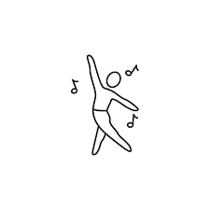

Narayana Junior College

NBKR Institute of Science and Technology

Computer Science & Engineering

SECONDARY EXAMINATION

SR. SECONDARY EXAMINATION

Undergraduate (2018-22)

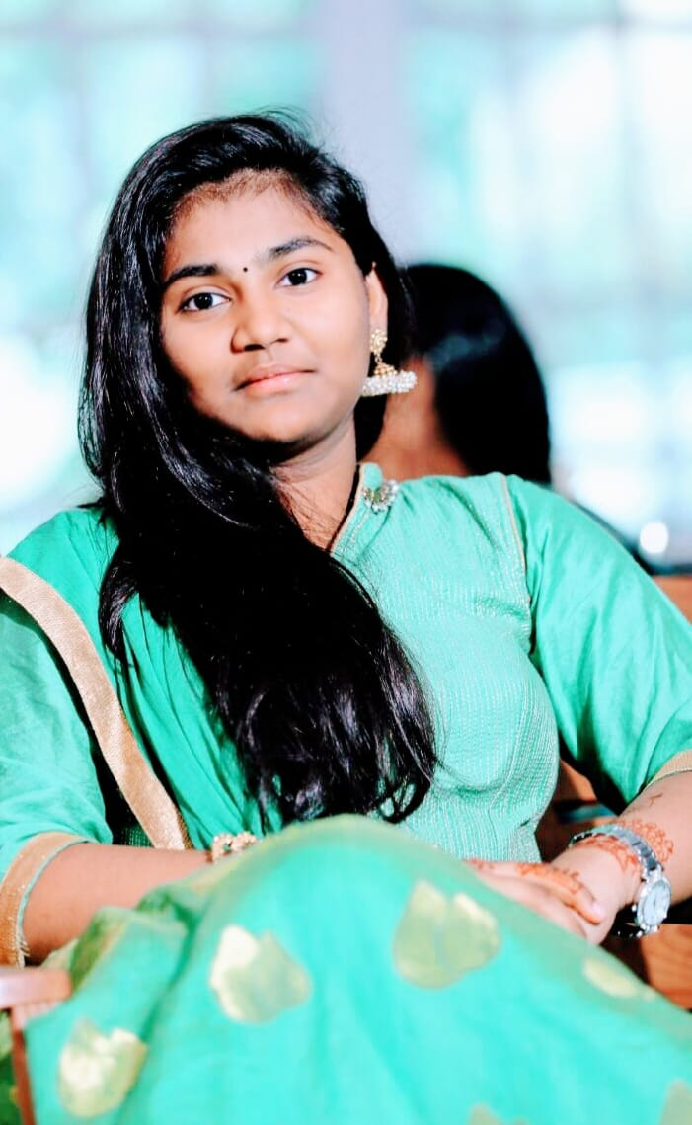

SQL

Skills

CSS

ashi.posina@gmail.com

7661859359

24/3/289, S.P.Bunglow Road, Dargamitta, Nellore – 524003

Date of Birth: November 12, 2000Age: 20Gender: FemaleBirth Place: Nellore, AndraPradesh

SSC Board of AP

Ratnam High School

State board of Intermediate AP

A software engineering graduate who is seeking to find a challenging position and a lively work environment that will encourage me to improve and learn new and necessary skills where I can grow personally and also contribute to the company’s growth using my excellence in communication, technical and organizational skill.

BACHELOR DEGREE

2016

2018

2016

2022

2018

2020

contact

about me

CAREER OBJECTIVE

INTERESTS

ACADEMIC BACKGROUND

ASHRITHA POSINA